British Culture Workshop Pilot Student Feedback - February, 2010

Overall 81 students attended the British Culture Workshop pilot run on the 24th of February 2010. Practical reasons dictated such a late date at the end of the second semester but the event was still very successful as confirmed by the feedback collected from the students. Since its first pilot, the British Culture Workshop has been offered in September 2010, as part of the University International Welcome Day and in February 2011 as part of the Erasmus and Visiting Students Welcome Activities.

A quick questionnaire was circulated at the end of the first pilot in February 2010 to gain the student perspective on the value of this kind of activities as a way of better supporting students in their transition into University. Overall 36 students returned their questionnaires giving us a response rate of 44%.

Respondents Level of Study
UG | 67%
PGT | 25%
PGR | 8%

Respondents Nationality
EU and EEA | 44%
International | 52%
Unknown | 4%

This Wordle* picture represents the respondents nationalities. The nationalities in bigger fonts are the ones that were most widely represented.

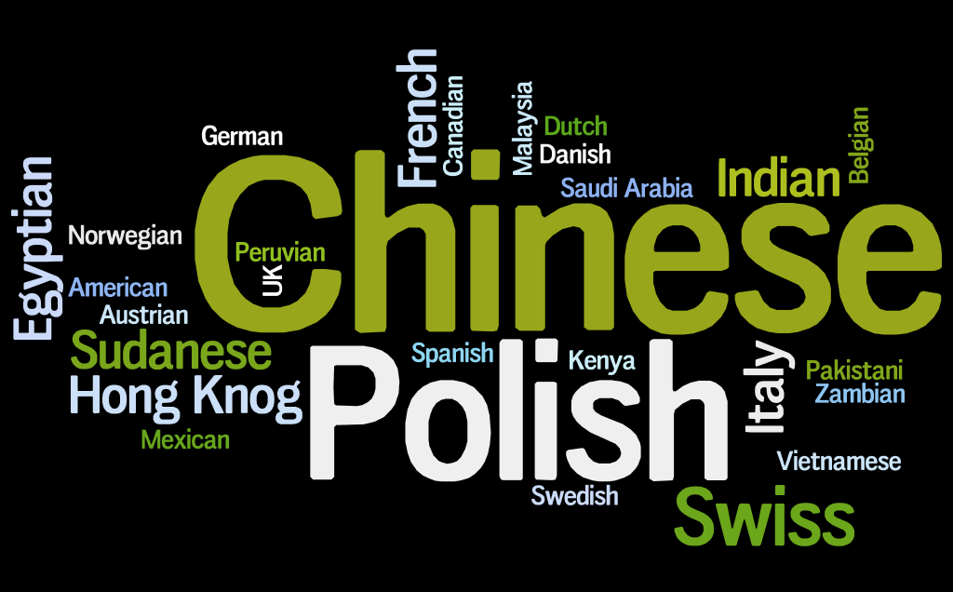
* http://www.wordle.net/

Main reason for coming

Student mentioned as main reasons for coming:

- Making friends
- Practicing English
- Free Coffee and Cake!
- Familiarising with British culture
- Familiarise with the University system
- Share experiences
- Get advice
- Gain information on resources and activities

What they liked the most

- Speaking with students from many different countries and cultures
- The relaxed atmosphere
- Sharing feelings and opinions in a “safe” environment
- Meeting students that are experiencing similar challenges
- Friendly Student Facilitators
- Event format
- Live questions and feedback made the event very interactive
- Get student and staff point of view

Things that could be improved

- Organise ice breaker games
- Allow groups to choose their own conversation topic
- Smaller discussion groups
- Have this event run mid way in semester one
- Leave more time for student interaction and meet other students
- More practical tips
- More distance between groups during discussion time to reduce level of noise in the room

Things that could have helped you to have a smoother transition

- More detailed e-mails about the administrative things to do
- Offer more warm-up information about life and study in Southampton
- Better advertising of events and activities
- Provide Student Handbook and information before arriving to Southampton to avoid information overload in the first weeks
- More social events for international students and events where International students and UK students can meet.
- More information about cultural differences during presessional
- Being assigned a student mentor
- Organise similar events more regularly
- More bus trips from Heathrow during the welcome week

A mix of communication channels was used to promote the event. The students rated e-mails and flyers on campus as most effective.

Most Effective Communication Channels
E-Mail | 71%
Flyer on Campus | 19%
Friends | 17%
Flyer in Hall | 8%
Posters in SUSU | 6%
Plasma Screen in Schools | 6%
Plasma Screen in Library | 4%
Plasma Screen in Career Destinations | 2%

